Reddit

Client_ID (PK)
Client_Secret
User_Agent
Username
Password
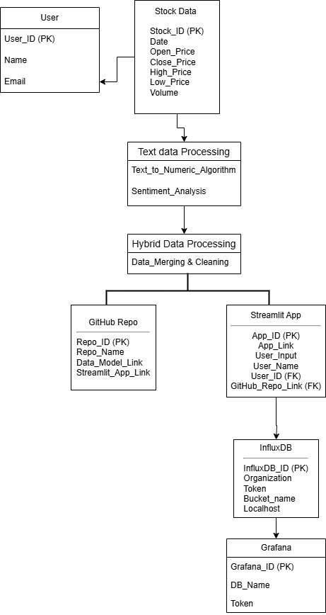





PowerBI

App_ID (PK)
Stock_ID (FK)

